**Practical Exercise - Walkthrough**

Since we are going to be working with Excel, the first step will be adding an **Excel Application Scope**and reading data from the sheet.

* Find and add an **Excel Application Scope**activityto the **Main** panel.
  + Insert the path of the downloaded .xlsx file in the **WorkbookPath** property field.
* Find and add a **Read Range** activity inside the **Do** container of the **Excel Application Scope**.
  + Insert a new DataTable variable, called *valuesTable*, in the DataTable property field.
  + Make sure that the **AddHeaders** check box is selected if there are headers.

Since the data is organized in a spreadsheet, a loop will be needed to iterate through each row.

* Find and add a **For Each Row** activity below the **Read Range**activity.
  + Set the **DataTable** to be looped through as *valuesTable***.**
* This is how the workflow should look like so far:

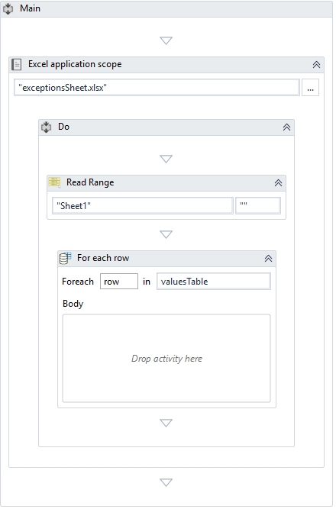

To write the resulting values in the proper cells, an **Index** variable will be needed.

* Find and add an **Assign**activity in the body of the **For Each Row**.
  + In the **To** field, create a generic variable called *rowIndex*.
  + It should assign *valuesTable.Rows.IndexOf(row) + 2*to *rowIndex*.
    - The + 2 is to compensate for UiPath’s DataTables starting at 0 instead of 1, as well as the increment for the header row in Excel.
* Find and add a **Try Catch**activity below the **Assign**activity.
  + This will catch exceptions if the Cash In is not a valid number.
* Find and add an **Assign**activity into the **Try** portion of the **Try Catch**.
  + Create a generic variable called *cashIn*.
  + It should assign *cint(row("Cash In"))* to *cashIn*.
    - This converts the cell value in the Cash In column of the current row to an integer and assigns it to *cashIn*.
    - If there is an exception (if the value is not a number), it will be caught in the **Catch** section.
  + Click on **Add new catch** at the bottom of the activity.
    - Select **SystemException** in the drop-down (search for it if it is not there).
    - Add a **Write Cell**activity into the exception area.
* Set the **Range** to *“C” + rowIndex.*
* Set the **Value** to *Cash In wrong.*

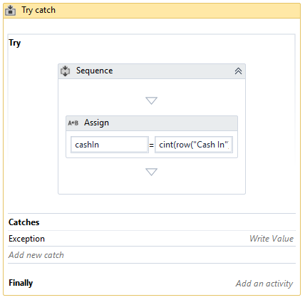

* Click back on the **Try** section: find and add another **Try Catch** below the **Assign**activity.
  + This one will *try* the *cash out* values and catch them differently.
* Add an **Assign** activity inside the **Try**section.
  + Create a generic variable called *cashOut*.
  + It should assign *cint(row("Cash Out"))* to *cashOut*.
* Find and add a **Write Cell**activity.
  + Its value should be *cashIn - cashOut*.
  + Its range should be *“C” + rowIndex*.
* For the **Catch**section of this **Try Catch**, add another **SystemException**.
  + Add a **Write Cell** in the **Exception** field.
    - Its **Value** should be “*Cash out wrong”*.
    - Its **Range** should be *“C” + rowIndex*.

This is how the final **For Each Row**should look like:

